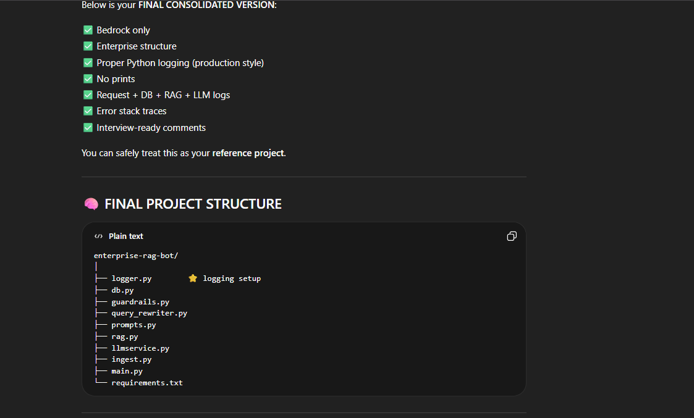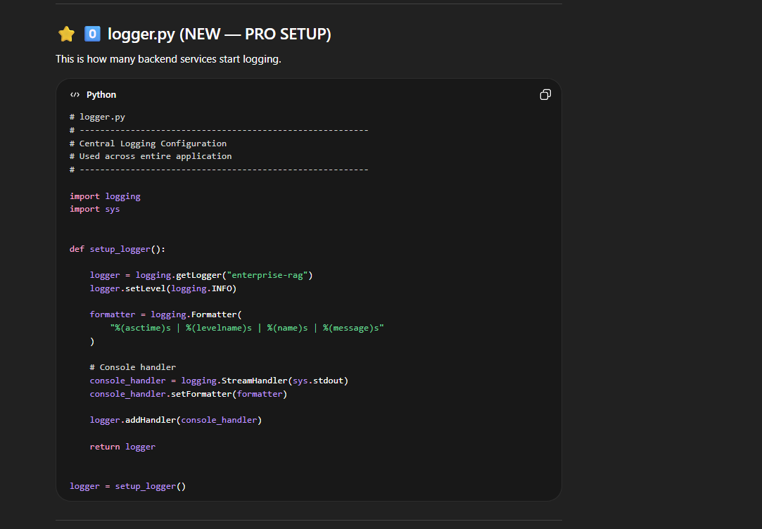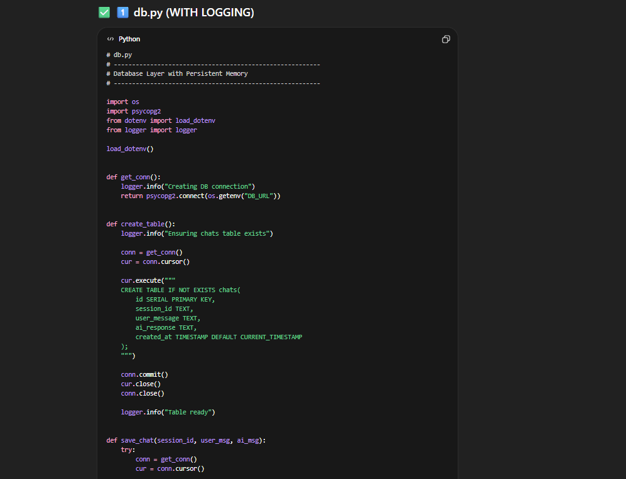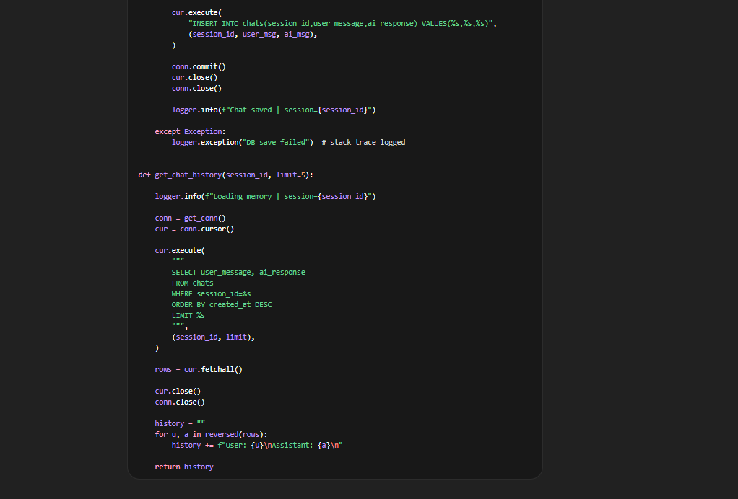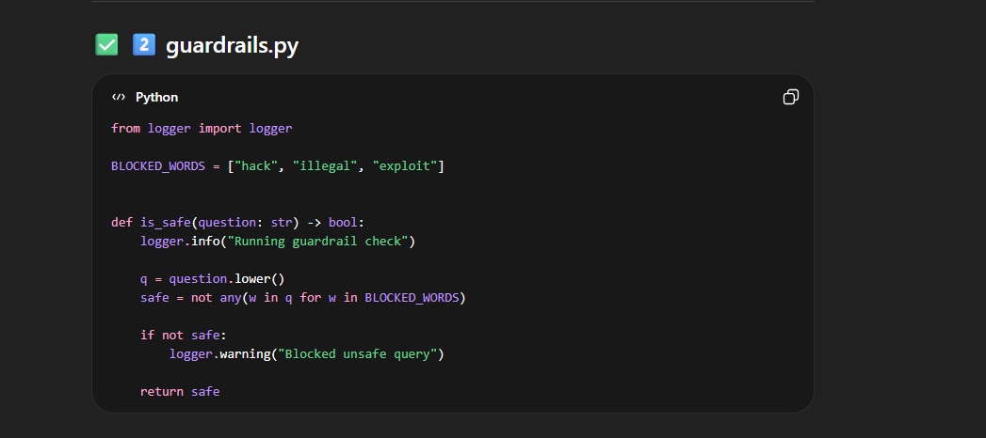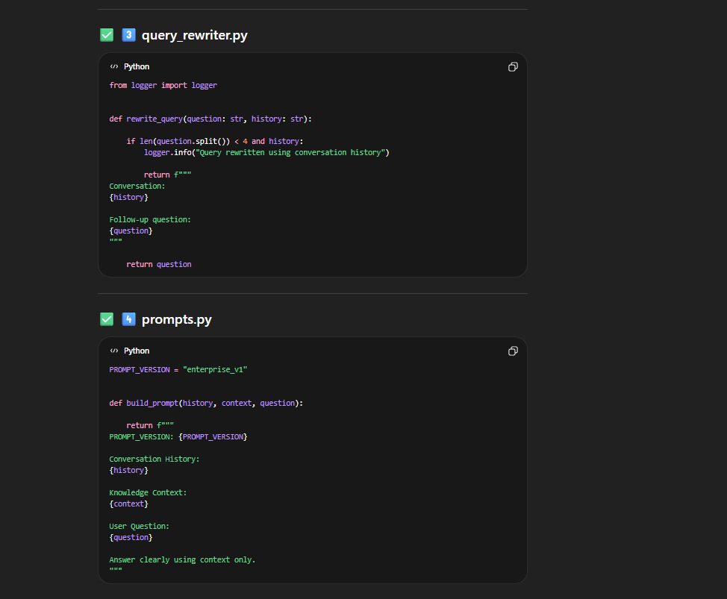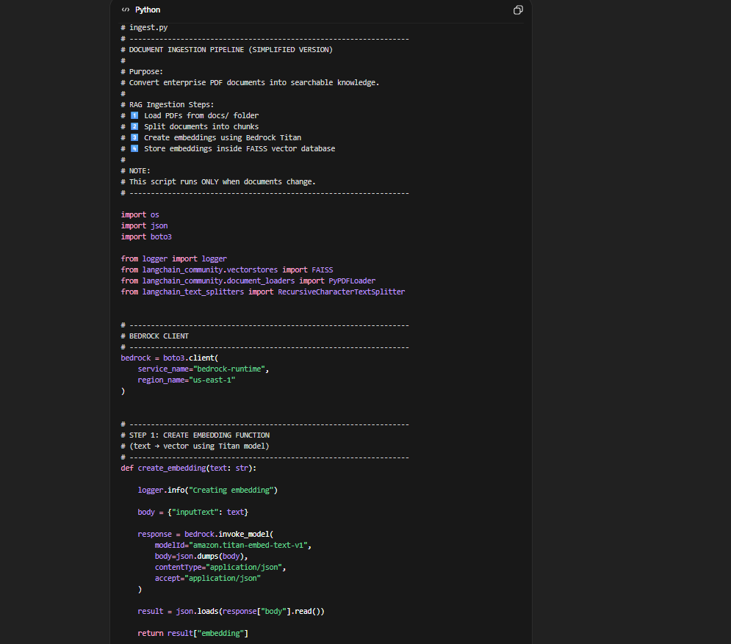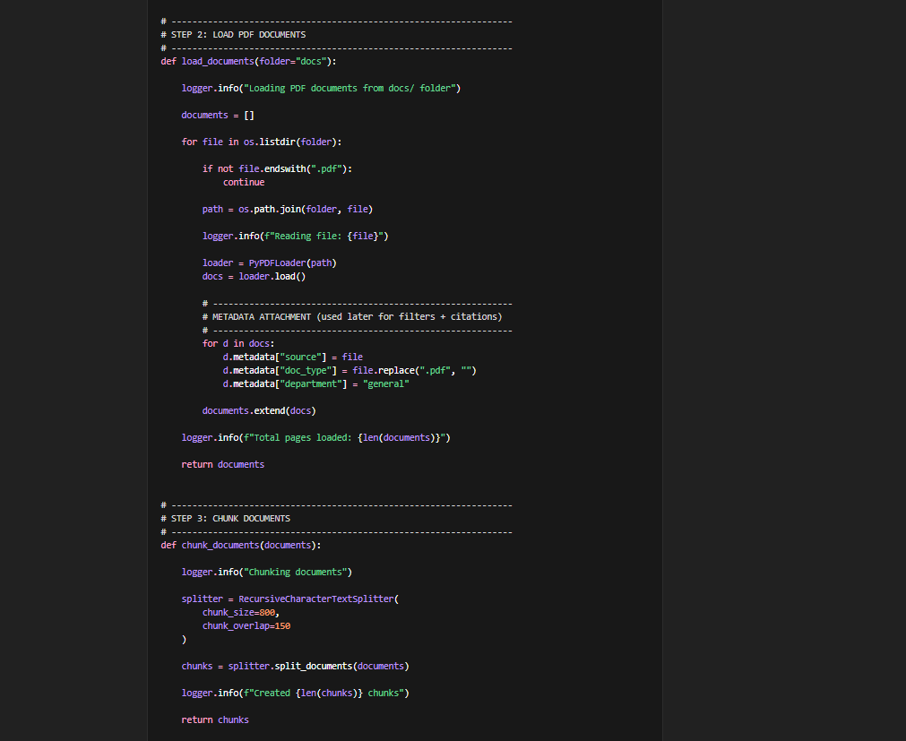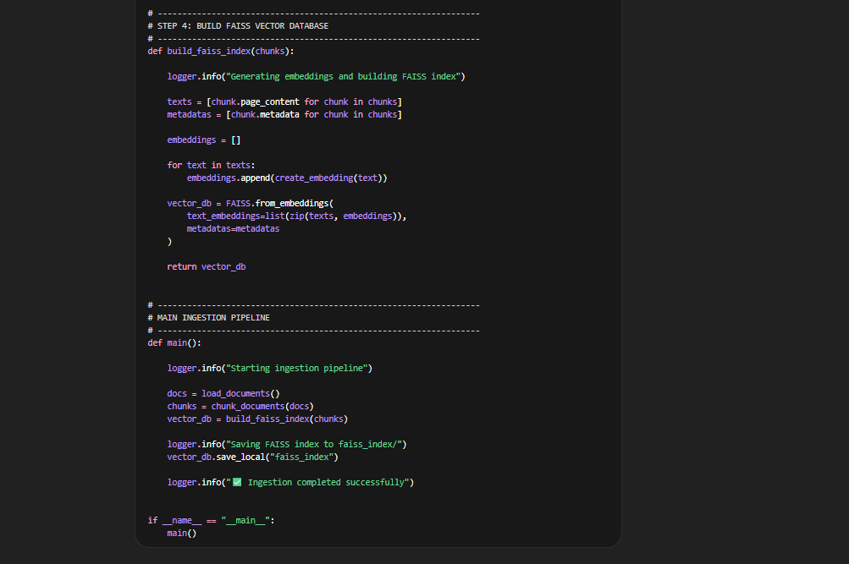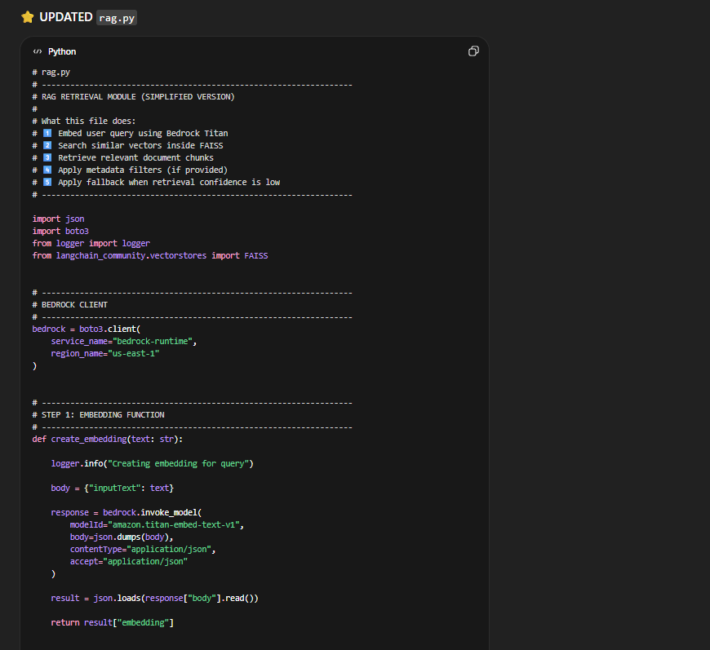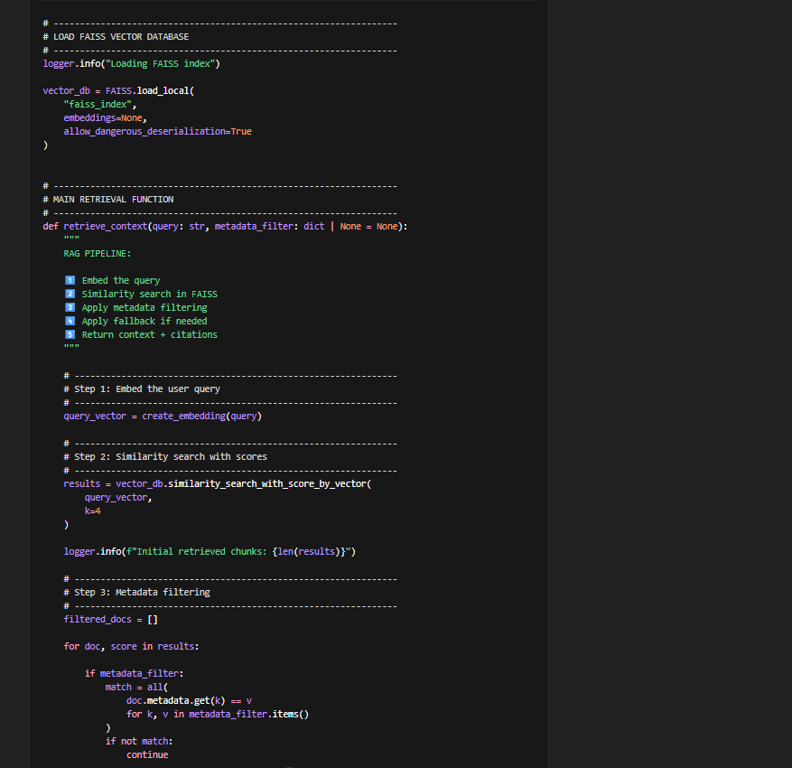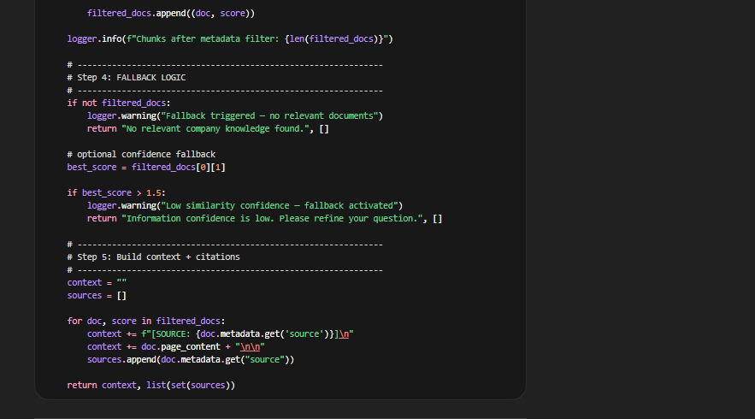
A chunk will look like above…
The main aim of “metadata filtering” is to reduce the Hallucination to model by not sending any unrelevant retrieved chunks….
Filtered_docs may look like(its just reference)
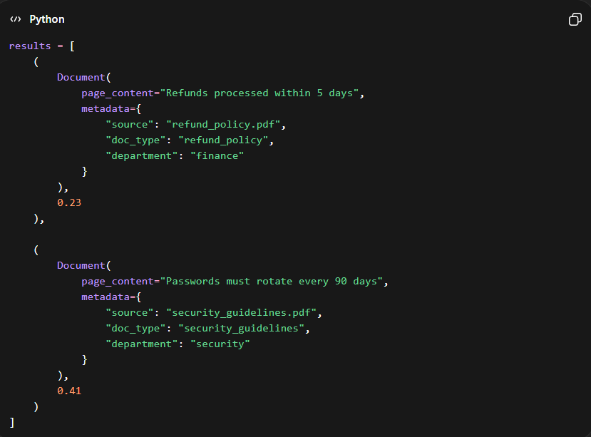
Consider filtered_docs =
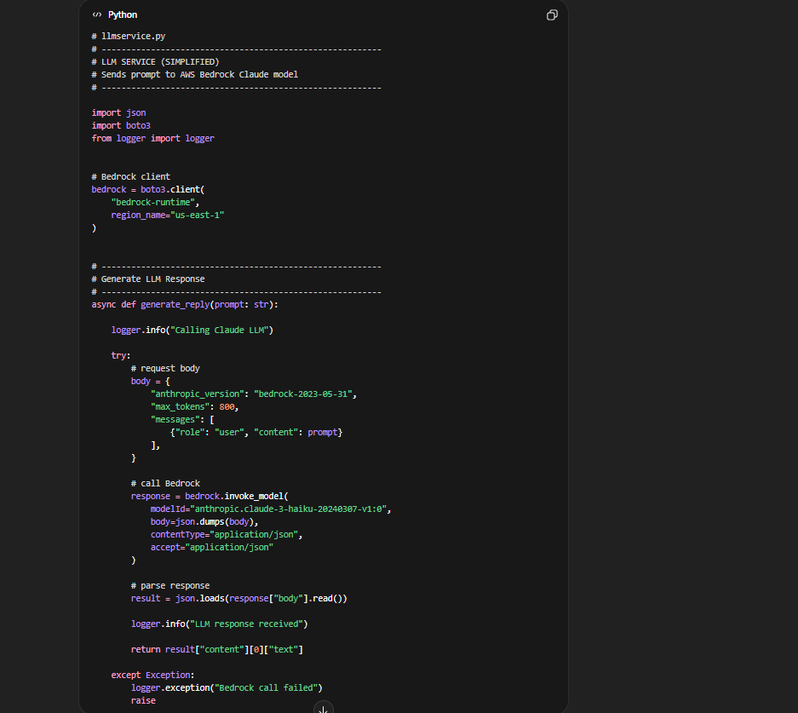

Explanations:
E-1:
Perfect — now we’ll slow down and go line-by-line, very calmly, like you’re seeing logging for the first time.
You are asking about logger.py, so let’s decode every single line.
Here is the code again (cleaned formatting):
import logging
import sys

def setup_logger():

logger = logging.getLogger("enterprise-rag")
logger.setLevel(logging.INFO)

formatter = logging.Formatter(
"%(asctime)s | %(levelname)s | %(name)s | %(message)s"
)

# Console handler
console_handler = logging.StreamHandler(sys.stdout)
console_handler.setFormatter(formatter)

logger.addHandler(console_handler)

return logger

logger = setup_logger()

🧠 Big Picture First (VERY IMPORTANT)
This file is doing only ONE thing:
👉 Create a professional print system for your entire project.
Instead of:
print("something happened")
you will use:
logger.info("something happened")

✅ Line-by-Line Explanation

1️⃣ Import logging library
import logging
Python already has a built-in logging system.
This gives you:
- logger.info()
- logger.error()
- logger.warning()
- logger.debug()
No installation needed.

2️⃣ Import sys
import sys
sys lets Python talk to system outputs like:
- terminal screen
- files
- streams
We use it to say:
👉 “Send logs to terminal.”

3️⃣ Create function setup_logger()
def setup_logger():
We wrap everything inside a function so we can:
- configure logging once
- reuse everywhere
Think:
Build logger → return ready-to-use logger.

4️⃣ Create a logger object
logger = logging.getLogger("enterprise-rag")
This creates a named logger.
Name = "enterprise-rag"
Why name?
Because large systems have many services:
auth-service
payment-service
rag-service
Logs show which service produced message.
Example output later:
INFO | enterprise-rag | Chat started

5️⃣ Set log level
logger.setLevel(logging.INFO)
This controls what messages are allowed.
Levels:
Level | Meaning
DEBUG | very detailed
INFO | normal events ✅
WARNING | something suspicious
ERROR | failure
You are saying:
👉 show INFO and above.

6️⃣ Create log format
formatter = logging.Formatter(
"%(asctime)s | %(levelname)s | %(name)s | %(message)s"
)
This defines how logs look.
Each part means:
Token | Meaning
%(asctime)s | timestamp
%(levelname)s | INFO / ERROR
%(name)s | logger name
%(message)s | your message
Output example:
2026-02-27 10:01:02 | INFO | enterprise-rag | Chat saved
This is why companies use logging — structured output.

7️⃣ Create console handler
console_handler = logging.StreamHandler(sys.stdout)
Handler = where logs go.
Here we say:
👉 send logs to terminal (stdout).
Later companies may send logs to:
- files
- cloud monitoring
- ELK stack
- Datadog
But concept stays same.

8️⃣ Apply format to handler
console_handler.setFormatter(formatter)
Without this, logs look messy.
Now every message follows your structured format.

9️⃣ Attach handler to logger
logger.addHandler(console_handler)
This connects:
logger → handler → terminal
Now logger knows where to send messages.

🔟 Return logger
return logger
Function gives back the configured logger.

1️⃣1️⃣ Create global logger
logger = setup_logger()
This runs setup immediately.
Now any file can do:
from logger import logger
and start logging instantly.

🧠 Visual Flow
logger.info("hello")
↓
logger object
↓
handler
↓
formatter
↓
terminal output

✅ Example Usage (Anywhere)
from logger import logger

logger.info("API started")
logger.warning("Low retrieval score")
logger.error("DB failed")
Terminal:
2026-02-27 | INFO | enterprise-rag | API started

⭐ Why This Is Professional
Because now you have:
✅ timestamps
✅ severity levels
✅ structured logs
✅ reusable logging system
This is exactly how backend services behave.

🧩 Simple Memory Trick
Logger = brain
Handler = speaker
Formatter = speaking style

If you want next, I can show you the 3 logging lines that instantly make interviewers think “experienced backend engineer” — tiny additions, big impact.

E-2:
Perfect — this is the right place to slow down.
You’re not confused because it’s hard — you’re confused because Python compressed many steps into one line (all()).
I’ll rebuild the whole thing visually + with real data, step-by-step.
No shortcuts.

🧠 Step 0 — WHY metadata filtering even exists
Without filtering:
User asks refund question
↓
FAISS searches ALL documents
(policy + security + refund)
Sometimes wrong domain chunks appear.
So we say:
“Search only inside specific documents.”
That’s metadata filtering.

✅ Step 1 — What results actually looks like
After FAISS search:
results = vector_db.similarity_search_with_score_by_vector(...)
results is NOT magic.
It looks like this:
results = [
(
Document(
page_content="Refunds processed within 5 days",
metadata={
"source": "refund_policy.pdf",
"doc_type": "refund_policy",
"department": "finance"
}
),
0.23
),

(
Document(
page_content="Passwords must rotate every 90 days",
metadata={
"source": "security_guidelines.pdf",
"doc_type": "security_guidelines",
"department": "security"
}
),
0.41
)
]
Each item =
(Document, similarity_score)

✅ Step 2 — What metadata_filter looks like
From API:
metadata_filter = {
"doc_type": "refund_policy"
}
Meaning:
ONLY keep refund_policy documents

✅ Step 3 — Loop starts
filtered_docs = []

for doc, score in results:
Iteration 1:
doc.metadata =
{
"doc_type": "refund_policy"
}

✅ Step 4 — The scary all() line
Current code:
match = all(
doc.metadata.get(k) == v
for k, v in metadata_filter.items()
)
Let’s EXPAND it.

What .items() gives
metadata_filter.items()
returns:
("doc_type", "refund_policy")
So:
k = "doc_type"
v = "refund_policy"

Expanded version (what Python secretly runs)
Your brain-friendly version:
match = True

for k, v in metadata_filter.items():

if doc.metadata.get(k) != v:
match = False
break
That’s ALL it is.

✅ Step 5 — Why doc.metadata.get(k) == v ?
We are asking:
Does this document belong to the requested category?
Example:
doc.metadata["doc_type"] = "refund_policy"
v = "refund_policy"
Check:
"refund_policy" == "refund_policy"
✅ TRUE → keep document.

Second document:
doc.metadata["doc_type"] = "security_guidelines"
Check:
"security_guidelines" == "refund_policy"
❌ FALSE → discard document.

✅ Step 6 — Why all() ?
Imagine filter had multiple rules:
metadata_filter = {
"doc_type": "refund_policy",
"department": "finance"
}
We require BOTH:
doc_type matches
AND
department matches
all() means:
ALL conditions must be true.

Equivalent logic:
if cond1 and cond2 and cond3:

✅ Step 7 — Why continue ?
if not match:
continue
Means:
Skip this document and go to next one.

✅ Step 8 — Final kept documents
After filtering:
filtered_docs = [
(refund_policy_document, 0.23)
]
Security document removed.

🔥 WHY we do ALL this (real reason)
Without filtering:
Refund question
→ security chunk appears
→ LLM confused
→ hallucination risk
With filtering:
Refund question
→ only refund docs searched
→ precise answer
Enterprise systems REQUIRE this.

🧠 Ultra-simple mental model
FAISS search = Google search
metadata filter = site:amazon.com filter
Example:
refund policy site:company_docs
Same idea.

⭐ One-line explanation (interview gold)
“Metadata filtering restricts retrieval results to documents matching specified attributes before passing context to the LLM.”

✅ What you just understood
You now know:
- what results looks like
- what metadata_filter looks like
- why k,v loop exists
- what all() does
- why equality check happens
- why filtering matters
This is actually mid-level RAG engineering logic.

If you want next, I can show a 5-line debug print version that lets you literally watch filtering happen live when running the API — that makes it click instantly.
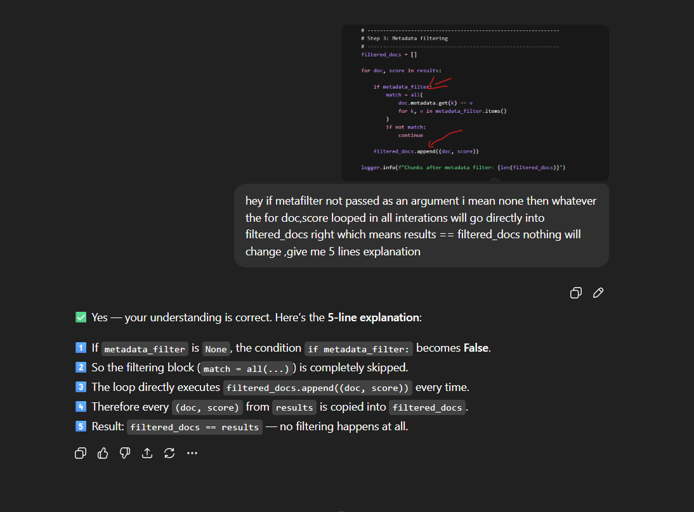

E-3:
Excellent — these are very sharp questions.
Both doubts come from mixing similarity score vs distance score, which is a SUPER common confusion.
Let’s fix both clearly.

✅ Doubt 1 — If nothing matches, will results become 0?
Short answer: ❌ No.
Even if query is unrelated, FAISS still returns k results.
You used:
k = 4
So FAISS always tries to return:
TOP 4 nearest vectors
Even if they are bad matches.

Example
Query:
"banana recipe"
Database:
security policies only
FAISS still returns:
results = [
(docA, bad_score),
(docB, worse_score),
(docC, very_bad_score),
(docD, terrible_score)
]
Because mathematically there is always a nearest vector.
So:
results length ≠ 0
Almost always.

When would results be empty?
Only if:
- FAISS index itself empty
- DB not loaded
- k = 0 (rare)
So your assumption:
no match → results = 0
❌ incorrect for FAISS.

✅ Doubt 2 — Why score > 1.5 ?
🔥 This is the important one.
You assumed:
score range = -1 to 1
That is TRUE only for:
cosine similarity
BUT…

🚨 FAISS (LangChain default) returns DISTANCE, not similarity
Your function:
similarity_search_with_score_by_vector()
returns:
L2 distance (Euclidean distance)
NOT cosine similarity.

Distance behaves opposite
Meaning | Distance value
Perfect match | 0.0
Close | small number
Bad match | larger number
Very unrelated | large number
So:
LOWER = BETTER
HIGHER = WORSE

Example distances
0.15 → very good
0.40 → good
0.90 → weak
1.60 → poor
2.30 → garbage

✅ Now score > 1.5 makes sense
This line:
if best_score > 1.5:
means:
distance too large → vectors far apart → low confidence
So fallback activates.

⭐ Key Realization
You were thinking:
similarity score
But code is using:
distance score
Opposite interpretation.

🧠 Quick Memory Rule
Similarity → higher is better
Distance → lower is better

🔥 Why FAISS uses distance?
FAISS indexes are optimized for:
L2 distance
Inner product
LangChain defaults to L2 unless explicitly normalized.

✅ Final Answers
Q1:
Will results be empty if nothing matches?
👉 ❌ No. FAISS still returns top-k nearest vectors.

Q2:
Why score > 1.5?
👉 Because score is distance, not similarity.
Higher distance = worse match → trigger fallback.

You just crossed one of the biggest conceptual hurdles in vector search.
This exact confusion separates beginners from engineers 👍.
You’re right to push here 👍 — let’s finish this properly.
The confusion is because “no match” ≠ “no results” in FAISS.
Let’s answer exactly why this condition can still become TRUE:
if not filtered_docs:

✅ First — What this condition means
if not filtered_docs:
means simply:
filtered_docs list is EMPTY
same as:
if len(filtered_docs) == 0:

✅ But FAISS always returns k results… right?
Correct:
results = similarity_search(..., k=4)
returns 4 nearest vectors.
So results is usually NOT empty.

🔥 KEY POINT YOU MISSED
filtered_docs is NOT the same as results.
We create it manually:
filtered_docs = []
Then we selectively add items.

✅ When DOES filtered_docs become empty?
Case 1 — Metadata filter removes everything (MOST COMMON)
Example:
Query:
"refund timeline"
FAISS returns:
results = [
(security_doc, 0.3),
(security_doc2, 0.4),
(policy_doc, 0.5),
(policy_doc2, 0.6)
]
User filter:
metadata_filter = {"doc_type": "refund_policy"}
Loop runs:
for doc, score in results:
Checks:
security_doc.doc_type == refund_policy ❌
policy_doc.doc_type == refund_policy ❌
Nothing passes filter.
So:
filtered_docs = []
✅ Condition becomes TRUE.

Case 2 — Wrong domain requested
User asks:
{"domain": "hr_policy"}
But DB has no HR docs.
Again:
all results filtered out

Case 3 — Future safety (defensive programming)
If retrieval logic changes later or DB partially fails.
Production code guards against empty lists.

🧠 Visual Flow
FAISS search → results (always k items)
↓
metadata filter removes items
↓
filtered_docs may become EMPTY
↓
fallback triggers

⭐ Why fallback is needed
Without this check:
best_score = filtered_docs[0][1]
would crash:
IndexError: list index out of range
So this line is also a safety guard.

✅ One-line truth
FAISS always returns neighbors, but metadata filtering can legally remove all of them.
That’s why:
if not filtered_docs:
is required.

You didn’t misunderstand — you just hadn’t seen the two-stage filtering effect yet.
This is actually a very real production edge case.

